Student mental health support at Curtin University - Report
Vasco Ramos de Melo Pimentel
18926563
Curtin University
September 2021

Prepared for:
Dr Sean Murray – Head of Curtin’s Psychological and Counselling Service
Dr Andrew Crane – Curtin University’s Chancellor
Hon. Sue M. Ellery – Western Australia’s Minister for Education
Executive summary
This report examines Curtin university’s effectiveness in providing mental health support for its student body. It seeks to answer whether Curtin’s Psychological and Counselling services are adequate to respond to the growing number of mentally distressed university students.
The report includes extensive research into the topic and draws data from a survey presented to Curtin university students. The conclusion of this report presents some potential shortcomings of Curtin’s Psychological and Counselling Services.
This report also includes recommendations based on research such as increasing the number of counsellors and extending triage appointment hours in order to improve Curtin’s mental health support to its students.

Table of contents
List of figures………………………………………………………………………………....4
- Introduction…………………………………………………………………….................5
- Mental health distress in Australian university students……..…………………………...5
2.1 Mental health in young Australian demographic……………………………………..6
    - Professional help-seeking in young Australian demographic..………………7
2.1.2 Main factors behind low levels of help-seeking in Australian university students……………………………………………………………………….............8
2.2 Main problems resulting from mental health distress for university students……….9
3. Survey findings…………………………………………………………………………….9
4. Curtin University’s mental health support services………………………………………..9
4.1 Wellbeing Advisory Service…………………………………………………………9
4.2 Psychological and Counselling Services……………………………………………10
4.2.1 Psychological and Counselling services: potential shortcomings……………..10
4.2.1.1 Low number of counsellors………………………………………………….10
4.2.1.2 Triage system………………………………………………………………...11
4.2.1.3 Wait periods………………………………………………………………….12
5. Conclusion…………………………………………………………………………………12
6. Recommendations…………………………………………………………………………12
7. Reference List……………………………………………………………………………...13
Appendices…………………………………………………………………………………...14

List of figures
Figure 1: Proportion of persons with a mental or behavioural condition, 2017-2018 (Australian Bureau of Statistics, 2018)………………………………………………………..6
Figure 2: Proportion of persons with anxiety-related conditions, 2014-2015 and 2017-2018. (Australian Bureau of Statistics, 2018)………………………………………………………..7

- Introduction
University students are subject to copious amounts of stress as they strive to meet the deadlines that prepare them for a professional career. Research shows that the number of mental health issues amongst Australian students is considerably high. Mental health problems can result from economic, biological, social and psychological factors, or a complex interplay between these. Numbers also show that Australians aged between 15 and 24 years-old are the most affected by anxiety-related and mental or behavioural conditions. So how are Curtin University’s Psychological and Counselling Services tackling the issue?
- Mental health distress in Australian university students
A mental health illness, such as depression or an anxiety-related condition, can be defined as a health problem that ‘can significantly affect how a person feels, thinks, behaves and interacts with other people.’ Numbers show that young Australians are the demographic most affected by these conditions. The transition to a university education is ‘itself associated with a range of emotional, social and academic demands that can cause psychological distress.’ Despite the presence of free counselling services available to Curtin students, the survey conducted for this report shows that only half of the students who responded were aware of the services available to them. Combine this lack of awareness with the social stigma associated with seeking professional help and you start grasping why a large number of students undergo university careers whilst ‘managing problematic symptoms, behaviours or an emerging or diagnosed mental disorder’ without seeking counselling.
This leads to lower academic performances and completion rates, along with an increased vulnerability in mental health for the young demographic.
Various studies have been conducted to point out the disturbing numbers, including the one by the Macquarie University Vice Chancellor, Professor Steven Schwartz, who reported that 10 to 15% of university students contemplated suicide at some point in their university career.

  - Mental health in young Australian demographic
A national mental health study conducted by the Australian Bureau of Statistics released in 2018 found that one in five Australians (20.1%) had a mental or behavioural condition. This study also showed that the age group most affected by a mental or behavioural condition was between 15 and 24 years of age (see figure 1 below).
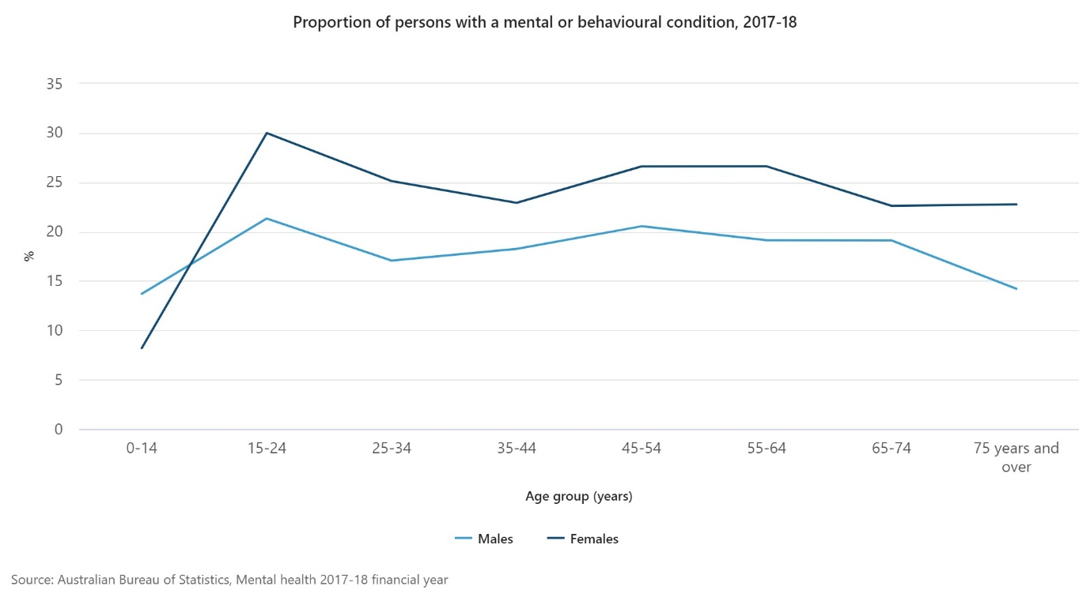
Figure 1
When analysing the proportion of the population with anxiety-related conditions between 2014-15 and 2017-18, young people aged between 15 and 24 make up for the most affected demographic once more (see Figure 2 below).
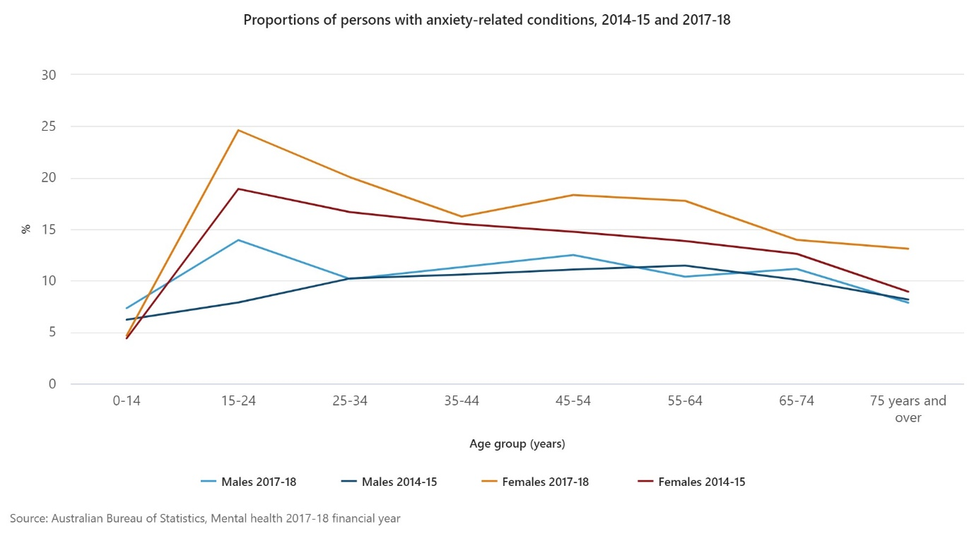
Figure 2
Considering the amount of data to prove how young Australians are the most affected by mental health and anxiety-related conditions, how many seek professional counselling?

    - Professional help-seeking in young Australian demographic
Despite the acknowledgement of a mental health issue affecting a whole demographic, data shows how young adults fail to or delay seeking help. A National Australian survey showed that ‘just under a quarter (23%) of young people with a mental disorder had accessed mental health services.’ Stallman and Shochet also analysed the phenomenon with a narrower scope on university students, reporting that 39% of university students with significantly high levels of psychological distress had not consulted a healthcare professional.

2.1.2 Main factors behind low levels of help-seeking in Australian university students
Wynaden et al. reported the main reasons for the observed low level of help-seeking in the Australian student demographic as:
- lack of recognition that the symptoms causing distress and interference with daily life may constitute a mental health problem;
- negative attitudes toward, and poor knowledge about, appropriate forms of help;
- perceived stigma;
- family reputation;
- age.

When dissecting their findings, Wynaden et al. also recognised the mental health profile of Australian university students as quite diverse, requiring a tailored strategic response.

  - Main problems resulting from mental health distress for university students
In their scholarly paper titled Students with mental health problems – A growing problem, Storrie et al. identified the most common problems originating from academic distress as depression, self-harm, social isolation, eating disorders, poor academic results, as well as decreased behavioural and social skills.

- Survey findings
The method employed for data collection in this report was a short survey presented to Curtin students. Despite the low number of responses (14), collected data showed that 85% of the students reported they had felt anxiety, depression and/or academic stress during their studies. All of the surveyed students replied they had not sought professional counselling at Curtin. Half of the surveyed students replied they were not aware of the counselling and support services available to them.
For a more detailed breakdown of the survey findings, see appendices.

4. Curtin University’s mental health support services
4.1 Wellbeing Advisory Service
The Student Wellbeing Advisory Service page on Curtin’s website shows a commitment to help its student body. ‘You are not alone at Curtin’, reads the opening sentence, followed by contact information, a confidentiality statement and the service’s availability – Monday to Friday. A somewhat detailed summary of what sort of services are available to the students, followed by some FAQs, help answer some important academic questions students might have.
This service reads more as a support for students looking for information on how to apply for a leave of absence or an assessment extension than mental health support per se. Considering how ‘academic demands can cause psychological distress’, these services should in fact help relieve some of the pressure faced by Curtin students.

4.2 Psychological and Counselling Services
For students whose mental distress demand professional counselling, the Psychological and Counselling Services page is also available on the Curtin website. Appointment hours run from 8am to 6pm from Monday to Thursdays, with the service availability ceasing at 4.30pm on Fridays. A confidentiality statement and an extensive list of potential reasons why people see a counsellor encourages students to seek professional help. Considering poor knowledge about appropriate forms of help is one of the main reasons behind the low levels of help-seeking in Australian university students , this accessible array of information at hand should prove useful.

4.2.1 Psychological and Counselling Services: potential shortcomings
4.2.1.1 Low number of counsellors
On closer look, one might argue that the service acts more as a safety net than an apt service itself. According to the Curtin website, the university saw a headcount enrolment of some 52,660 students in 2020. When analysing the list of professional counsellors available to students at Curtin, nine counsellors (including the Head of Service) are listed in the university’s website. Considering the overall research presented in this report to support evidence on the significance of mental distress among university students, the one counsellor per 5,851 students ratio falls short of adequate counselling resources.

4.2.1.2 Triage system
If a student is new to the service or has not had an appointment with a counsellor for the past six months, they must undergo a triage session with Curtin’s triage counsellor. A brief assessment of the student’s needs will follow based on the ‘urgency and complexity’ of the situation. This tailored approach may in fact prove useful in assessing the extent of the mental health distress the student is experiencing at the time of the initial appointment.
But on closer look, even though the counselling service itself runs from 8am to 6pm from Monday to Thursdays, and from 8am to 4.30pm on Fridays, triage sessions are held only between 9am and 12pm, from Monday to Friday. This means that if a student has not sought professional help before or in the past six months, and decides to seek counselling any time after 12pm, they will need to wait until the next day. Considering the data presented in point 2.1.1. in this report, this factor might contribute to the low levels of help-seeking amongst university students.

4.2.1.3 Wait periods
‘There may be a waiting period of up to four weeks during our busy times of the year.’ The fact that students might need to wait up to a month to see a counsellor is alarming.
- Conclusion
Research proves that young Australians are the most affected by a mental or behavioural condition, and how academic demands effectively increase these distress levels. Considering the low number of counsellors per student and the fact that students might have to wait up to a month to get help from a professional counsellor, it is arguable that Curtin University must increase its output of mental health support for its student body.

- Recommendations
- Increasing the number of counsellors available to students in order to decrease potential wait periods;
- Extending the counsellor and triage appointment hours – students need around the clock mental health support;
- Increasing Curtin student body’s awareness of the support services available to them.

- Reference list
Ahern, K., Storrie, K. & Tuckett, A. (2010). A systematic review: Students with mental health problems – A growing concern. International Journal of Nursing Practice. 16: 1-6.

Australian Bureau of Statistics. (2010). Mental health of Young People, 2007. ABS.
https://www.abs.gov.au/ausstats/abs@.nsf/mf/4840.0.55.001

Australian Bureau of Statistics. (2018). Mental Health. ABS. https://www.abs.gov.au/statistics/health/health-conditions-and-risks/mental-health/latest-release

Curtin University. (n.d.). Curtin University Student Statistics 2016-2020. Office of Strategy and Planning. https://planning.curtin.edu.au/stats/student_stats.cfm

Curtin University. (n.d.). Psychological and Counselling Services. Curtin Current Students. https://students.curtin.edu.au/personal-support/counselling-guidance/counselling/

Curtin University. (n.d.) Student Wellbeing Advisory Service. Curtin Current Students. https://students.curtin.edu.au/personal-support/counselling-guidance/wellbeing/

Department of Health. (2009). Fourth National Mental Health Plan – an agenda for collaborative government action in mental health 2009-2014. Department of Health. http://www.health.gov.au/internet/publications/publishing.nsf/Content/mental-pubs-f-plan09-toc;

Murray, S., Wichman, H. & Wynaden, D. (2013). A synopsis of the mental health concerns of university students: results of a text-based online survey from one Australian university. Higher education research and development. 32:5, 846-860, DOI: 10.1080/07294360.2013.777032

Schwartz, S. (2008, February 20). Don’t fail your friends. The Australian: Higher Education Section. Retrieved Sept, 2021, from http://www.vc.mq.edu.au/press-coverage/press-coverage610.pdf

Stallman, H., & Shochet, I. (2009). Prevalence of mental health problems in Australian university health services. Australian Psychologist, 44(2), 122–127.
Appendices
Survey findings (Conducted on SurveyMonkey.com)
Number of responses: 14
Q1: How old are you?

Q2: How long have you been enrolled at Curtin?

Q3: Are you aware of the psychological and counselling services available to you at Curtin university?

Q4: Have you ever felt anxiety, depression and/or academic stress during your time at university?

Q5: Have you ever sought counselling support at Curtin university?

Q6: How likely are you to seek professional counselling/support from Curtin if you need it?

 | Excellent (85-100%) | Good (70-85%) | Satisfactory (55-70%) | Needs attention (45-55%)
Content (20 marks)
- Articulates critical understanding of key concepts and themes of tertiary student-based issue. | Articulates excellent critical understanding of key concepts and themes of selected tertiary student-based issue. | Articulates good critical understanding of key concepts and themes of selected tertiary student-based issue. | Articulates sound understanding of key concepts and themes of selected tertiary student-based issue. | Does not articulate understandings of key concepts and themes of selected tertiary student-based issue.
- Engages with credible and reliable research | Research presented is thorough, credible and reliable. | Research presented is thorough, credible and/or reliable. | Some research presented is credible and/or reliable. | Research presented is not credible and/or reliable.
- Offers valid and purposeful recommendations | Recommendations are impressive, purposeful and valid for stakeholders. | Recommendations are purposeful and/or valid for stakeholders. | Some recommendations are purposeful and/or valid for stakeholders. | Recommendations are not purposeful and/or valid for stakeholders.
Written expression and presentation (20 marks)
- Use of appropriate report format and structure | The format and structure of the report is flawless. | The format and structure of the report is nearly error-free. | The format and structure of the report has few errors. | The format and structure of the report has many errors.
- Clear syntax and language; correct punctuation, grammar and spelling | The report uses language beautifully and without errors. | The grammar, syntax and spelling of the report is nearly error-free. | There are a few errors of grammar, syntax or spelling. | There are many errors of grammar, syntax and spelling.
- Presentation in required format (length, double spacing, size 12 font, proofread, sources correctly footnoted and reference list in APA 7th) | Strong, clean presentation and all sources are correctly referenced in report style. | Most presentation requirements met with most sources are correctly referenced in report style. | Meets some presentation requirements with some sources are correctly referenced in report style. | Poor presentation and many references missed or incorrect.

Grade: /40
Feedback:

Department of Health, 2009.
Murray, Wichman & Wynaden, 2013, p.1
Murray, Wichman & Wynaden, 2013, p.1
Schwartz, 2008, n.d.
Australian Bureau of Statistics, 2018.
Australian Bureau of Statistics, 2018.
Australian Bureau of Statistics, 2010.
Stallman & Shochet, 2009, p.4
Murray, Wichman & Wynaden, 2013, p.3
Murray, Wichman & Wynaden, 2013, p.4
Storrie, Ahern & Tuckett, 2010, p.2
Curtin University, n.d. Student Wellbeing Advisory Service.
Murray, Wichman & Wynaden, 2013, p.1
Murray, Wichman & Wynaden, 2013, p.3
Curtin University, 2021. Office of Strategy and Planning.
Curtin University. n.d. Psychological and Counselling Services.
Curtin University, n.d. Psychological and Counselling Services.

